Fairytale Rollercoaster
(A 3rd-Grade Language Arts Project-Based Learning Experience)
Provocation - Pictures of new ride at Disney World based on Snow White - discussed what they are doing?; are they working in isolation or as a team?
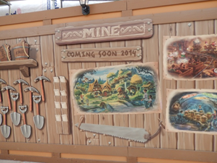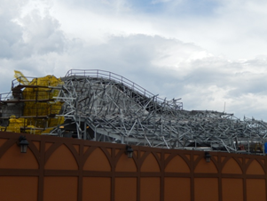
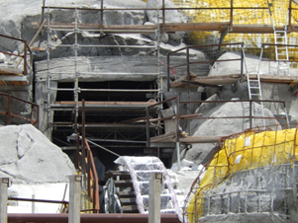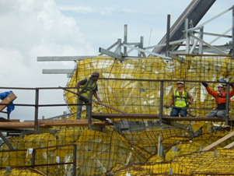
Common Core and Essential Standards:
L. Arts - (3.RL 3) RECOUNT (retell) stories - fairytales

Science - (3.P.1.1) - Students know that when a force acts on an object it will result in a change of speed and / or direction. (3.P.1.2) Students know that speed can vary. Students know that varying the speed of a moving object will affect the time it takes for the object to travel a particular distance. (3.P.1.3) Students know that the earth ‘pulls’ on all objects on or near the earth without touching those objects

Technology - (3.TT.1) Use technology tools and skills to reinforce classroom concepts and activities (3.RP.1) Apply a research process as part
of collaborative research.

Present PBL:
Disney is looking to create a new park dedicated to classic fairytales. They have hired your engineering team to design a fairytale rollercoaster. You must make a rollercoaster model for them to evaluate. The rollercoaster must have at least two props that show fairytale elements from your chosen story. Your team also needs to present images and information about the country the fairytale originates from so Disney Imagineers can develop the area around the rollercoaster. Additionally, Disney wants your team to recount your chosen fairytale so they can have the story broadcasted during the ride to bring the joy of this story to the many children they anticipate will ride your rollercoaster.

Students chose to present to 2nd graders since they did not know what made a fairytale, a fairytale as third-graders before this project.

Details created by students:
PowerPoint slide – Recount (retell) of the Fairytale
PowerPoint slide – Elements in your fairytale
- Royalty – (how is this in your story)
- Numbers connections (3 wishes; 7 dwarves…)
- Once upon time or long, long ago
- Good vs. evil (example)
- Magic (example)
- Problem – how is it solved
- Happily ever after
PowerPoint slides– Country of fairytale origin
- Country name and a picture of the country (map)
- Continent the country is on
- Food or drinks – must label the names of them
- 2 animals must be from that country!
- Language – Fairytale –(what is this in that language) - Google translate
2 Props – MUST show 2 different elements

Rollercoaster Tests

TESTS | What happened? (How many times did you have to push the marble?) | What changes did your team make to the rollercoaster?
Test #1

Test #2

Test #3

Our Fairytale Rollercoaster Rubric – 3rd Grade
Task | Total Amount of Points | Points Earned
Rollercoaster – the marble is able to show movement when pushed | 5 points
Rollercoaster Creativity – uses more than one angle to move the marble | 10 points
Rollercoaster Tests – able to explain tests and the changes they made as a result of the test | 12 points
Fairytale Prop 1 – prop represents one of the fairytale elements in the chosen fairytale | 5 points
Fairytale Prop 2 – prop represents one of the fairytale elements in the chosen fairytale | 5 points
Fairytale Retell – May be done in MS Word or MS PowerPoint - Must be in the students’ own words – must also include the fairytale elements in the story | 20 points
Place of Origin (Where does the fairytale come from/take place?) Done in MS PowerPoint - need name and picture of country; the continent the country is on; foods and drinks from this country; 2 animals; Language page to write the word “Fairytale” in the language of this country | 15 points
Teamwork – Working in teams without arguing, sharing tasks and completing project on time | 12 points
Presentation to 2nd grade class – voice is loud enough to hear when retelling fairytale and introducing country; able to explain rollercoaster | 16 points

