Parachute Drop (STEAMED UP)
Grades K-1
http://www.youtube.com/watch?v=p2cmOJEFaZM (instructional video 8minutes for teacher)
Purpose: To explore how different materials react to different forces.

Guiding Questions:
1. What is a force?
2. What types of forces are there?
3. How will we count the seconds of the fall? (1-1000 or 1-parachute and so forth)
4. How high do all parachutes need to be before they are dropped? (Can use a non-standard measurement)
5. How do scientists record their data? (In this case—time)
6. Was the falling of the parachute a push or pull force? (First grade-1.P.1.1)
7. How can we describe how the parachute fell to the ground? (Kindergarten – K.P.1-science) straight, zigzag, round and round, back and forth, fast or slow.

Materials:
Coffee filters
Thin plastic bag
Wax paper
Thin cloth
Cheesecloth or gauze
3 to 15 strings for each parachute
1 heavy paper clip or three identical small weights
What to Do:
- Cut out three parachute circles, all the same diameter
- Attach 3-15 strings to each parachute. Use the same number of strings.
- Have students feel the textures of each parachute and predict which one they think will drop the slowest? Fastest? Have a chart for each to place a sticker by the one they think will fall the slowest/fastest. (Reference Art K.V.1.4 (texture); 1.V.1.4 (texture)
- Drop each chute from the same height. (The higher you start the drop, the better your results.) Count how long each parachute takes to reach the ground.
- Collect the data on a board, chart paper or on the computer.
- Which material made the slowest drop? Why?
- Which material made the fastest drop? Why?
Example graph:
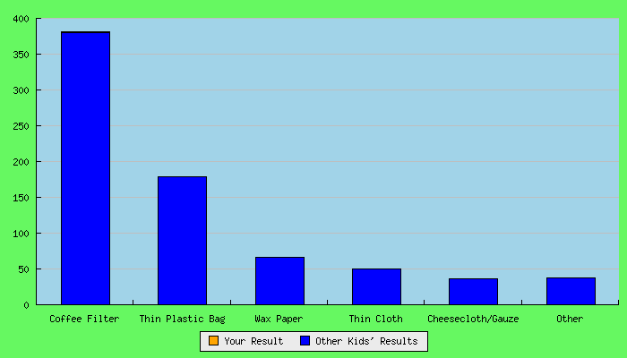

What's happening?
Hopefully your parachute will descend slowly to the ground, giving your weight a comfortable landing. When you release the parachute the weight pulls down on the strings and opens up a large surface area of material that uses air resistance to slow it down. The larger the surface area the more air resistance and the slower the parachute will drop.
Cutting a small hole in the middle of the parachute will allow air to slowly pass through it rather than spilling out over one side, this should help the parachute fall straighter.
Art Connections
Leonardo Da Vinci
- Was the first to imagine a parachute but no proof if he ever tested it-
- http://legacy.mos.org/sln/Leonardo/Leo-Parachute.jpg
- www.da-vinci-inventions.com/parachute.aspx

Real World/Global Connections
-What are parachutes used for?
- Fun (skydiving)-events all around the world
-military
- Spacecraft re-entries into the water
** The original use was intended as an emergency device in tall building in case there was a fire.
Technology
- Using the computers to generate graphs for discussion.
- Watching videos on real parachutes in action and discuss similarities and differences with the classroom differences.
Engineering
-Creating the parachute
-determining the number of strings, the type of material, the size of the circle or even if it is a circle.

